Exploring Diverse Effects of Four Types of Mobility on University Entrepreneurship

Satoko Yasuda ^{a*,} ^{b}
* Corresponding Author. Tel: +81 798 546205
E-mail: yasuda-satoko@kwansei.ac.jp
ª School of Business Administration, Kwansei Gakuin University
yasuda-satoko@kwansei.ac.jp
^{b} Innovation Research Center, Kwansei Gakuin University

Abstract
This study explores the mechanism by which mobility influences university entrepreneurship through an empirical analysis of Japanese scientists working for the University of Tokyo. It presents theory-driven typology of mobility and applies it to the knowledge-transfer context. First, this paper subdivides previously-studied mobility into four types – job mobility (JM), sector mobility (SM), international mobility (IM), and the educational background mobility (EBM). Then, it empirically shows that both JM and IM have positive and significant correlation with university entrepreneurship, whereas neither SM nor EBM does. Based on the result, this study discusses that JM and IM accelerate the formation of skills necessary for the commercialization of university research; however, SM and EBM may have no impact on it.

Keywords: Entrepreneurship, Technology transfer, University research commercialization.

INTRODUCTION

Mobility of Academic Entrepreneurs
The objective of this paper is to describe how the mobility affects the entrepreneurship among Japanese scientists. It draws on the literature on entrepreneurial activity of university scientists in the form of new firm creation (e.g., university spin-offs). This paper highlights academic entrepreneurs (AEs) that are defined as “university scientists creating university spinoff companies and developing their lab discoveries to meet industrial and social demands (Shane, 2004).” The study is based on the theory-driven assumption that “spinoff behaviour of AEs is a reflection of individual actions and therefore is largely due to the personality, ability or willingness of the individual to engage successfully in entrepreneurial behaviour (O’Shea et al., 2004).”
A new set of data comprising credible and wide-ranging information facilitated the empirical analyses of more than 500 scientists holding full-time positions at the University of Tokyo (UOT). First, the study distinguishes between Japanese academic entrepreneurs (AEs) and non-AEs. It then compares the career paths of AEs and non-AEs, highlighting four kinds of mobility: job mobility (JM), sector mobility (SM), international mobility (IM), and educational background mobility (EBM).
The result of the probit analysis clearly shows that both JM and IM are positively related to university entrepreneurship among Japanese scientists, whereas SM and EBM are not.

Background
In 1980, the US government enacted the Bayh-Dole (BD) Act (U.S. Law 96-517, Patent and Trademark Act Amendments of 1980). Japan has introduced the BD-like legislation expecting to catch up with the US system of innovation. Between 1998 and 2004, the Japanese government enacted several laws, all of which were expected to encourage university scientists to transfer and commercialize their research outcomes (Baba et al., 2009; Collins and Wakoh, 2000; Kneller, 2007; Walsh et al., 2008; Harayama et al., 2009). During the same period, the government offered incentives to university researchers such as generous financial support in order to enhance their entrepreneurship.
However, some have been skeptical about the effectiveness of Japan’s BD-like legislation in enhancing university entrepreneurship (Harayama et al., 2009; Collins and Wakoh, 2000). They argued that, for at least several years after the BD-like legislation was enacted, there was no robust evidence to show that innovation system in Japan had shifted towards U.S.-like system, in which university scientists are very eager to create spinoff firms in order to transfer university inventions (Kneller, 2007). In the same vein, Harayama et al. (2009) asserted that some of the policy initiatives carried out in accordance with the legislation actually hindered entrepreneurship among university scientists.
Though Japan attempted to introduce BD-like laws in order to adopt a U.S.-style innovation system that encourages university spinoffs, it still substantially lags behind the U.S.A. in the number of new spinoff firms and firm-founding scientists. Institutional differences between the U.S.A. on one side and Japan on the other are considered among the major factors responsible for the lag.
The difference between the U.S.A. and Japan is also attributable to the individual characteristics of scientists working for their universities. The relationship between entrepreneurship and individual characteristics of university scientists is frequently studied. Some have highlighted psychological aspects such as motivation (Sauerman et al., 2010), value orientation towards commercial activities (Lam, 2011), and role identity (Libaers and Wan, 2012). Others focused on scientists’ mobility as reflected in their career paths. Most of the research in this stream confirmed that high mobility is significantly related to enhanced entrepreneurship among scientists (Stephan and Levin, 2001; Hunt and Gauthier-Loiselle, 2008; Edler et al., 2011; Krabel et al., 2012).
Though empirically robust, the findings of above-mentioned papers might have underestimated the level of mobility of some of the scientists. Some articles evaluate mobility using scientists’ foreign-born backgrounds (Stephan and Levin, 2001; Hunt and Gauthier-Loiselle, 2008; Libaers and Wan, 2012), which might have missed many native-born scientists who had stayed in foreign countries for a long time and then returned home. Articles that collected data from online surveys (Edler et al., 2011) may also not be free of underestimation since there is no guarantee that the scientists’ career paths were disclosed in detail.
This study attempts to alleviate this underestimation problem. It collected individual scientists’ career path data from their CVs posted on websites maintained by organizations that have the right or a good reason to collect scientists’ career-path information. Furthermore, detailed career path data enables the study to subdivide the mobility into four categories: JM, SM, IM, and EBM. The study subsequently examines how respective categories influence the formation of entrepreneurial skills of a mobile scientist. Thus, this study will be able to contribute to the literature through a detailed examination of whether mobility encourages university scientists to become AEs.

ANALYTICAL FRAMEWORK

Theoretical development and hypotheses

Job mobility and university entrepreneurship

This study divides scientists into two groups: scientists who have moved to their current affiliation from other universities fall into the high-job mobility (JM) group, while those who have stayed at their current affiliations since being hired full-time comprise the low-JM group.
Scholars who investigated the relationship between JM and university entrepreneurship approached the topic from one of the two perspectives: researchers’ intrinsic factors, such as motives and preference for entrepreneurial behaviours, or AEs’ access to both knowledge and human networks as joint supports for their entrepreneurial endeavours.
McKenna (2003) and Thorn (2009) are among those who highlighted researchers’ intrinsic factors, indicating that scientists’ career motives, not financial incentives, drive them to be mobile. Similarly, Lam (2011) focused on intrinsic factors and revealed that heterogeneous motives drive academic scientists into commercial endeavours. She drew from social psychology theory to discuss how personal motivation affects scientists’ commercial engagement. In the same vein, Sauermann et al. (2010) surveyed data on more than 2,000 U.S. academic scientists and clearly showed the significant relationships between their motives and entrepreneurial activities.
Scholars who focused on AEs’ access to both knowledge and networks often indicated that entrepreneurs seek innovation by recombining different types of knowledge. As the theory of “sticky knowledge” argues, place-specific or context-embedded knowledge is immobile (Asheim and Isaksen, 2002). This theory implies that JM enables entrepreneurs to access fresh knowledge embedded in the organization to which they have just moved. It also implies that, when an entrepreneur envisions a new combination of the fresh knowledge with the familiar knowledge that he/she had learned at the previous affiliation, the entrepreneur clearly recognizes an opportunity for innovation.
Entrepreneurs are also able to build relationships with new colleagues, some of whom contribute ideas for innovation. As a quid pro quo, entrepreneurs may transfer knowledge from their previous affiliations which would be considered fresh by their new colleagues. This process of knowledge exchange facilitates mobile entrepreneurs’ skill formation that is important for the commercialization of university research.
From the discussion above, this study postulates a proposition regarding JM: in academia, JM fosters entrepreneurial savvy, and thus JM and the likelihood of creating spinoff firms are positively correlated. This proposition leads to the first hypothesis:

H1: University scientists who have JM are more likely to be AEs than are their non-mobile peers.

Sector mobility and university entrepreneurship

University scientists with work experience in the industrial sector comprise the high sector mobility (SM) group, while those who have stayed in the university sector for their entire professional lives comprise the low SM group.
The literature on knowledge transfer among universities and businesses frequently indicated the gap between these two sectors. Some scholars addressed the gap as a mismatch between the knowledge created in universities and the requirements for its commercial exploitation (Wright et al., 2007b); others viewed this gap as a knowledge filter that prevents knowledge from becoming economically useful (Carlsson et al., 2009).
The literature often indicates, however, that there are factors that help AEs fill the gap or overcome the filter. For example, direct communication among the persons involved – those participating in knowledge exchange from both universities and companies – has been extensively studied. Research in this stream often discovered that direct communication is supported by face-to-face interactions among academic scientists and company researchers (Balconi and Laboranti, 2006), by consultancy and joint research conducted by both academics and business people (D’Este and Patel, 2007), and by social networks of academics developed through prior business owner experience (Mosey and Wright, 2007).
From the discussion above, this study postulates a proposition regarding SM: SM provides scientists with opportunities to have direct communication with businesspeople, which subsequently helps scientists fill the gap or overcome the filter between academia and industry. This proposition leads to the second hypothesis:

H2: University scientists with SM are more likely to be AEs than are their non-mobile peers.

International mobility and university entrepreneurship

Research on international mobility (IM) often observed that scientists’ entrepreneurship is associated with their overseas experience or foreign backgrounds. These studies mainly drew on theories developed in three fields: labour migration, sociology, and innovation studies.
Studies employing the labour migration theory indicated that overseas experience improves migrants’ risk perception, making them less risk averse. Individuals who are less risk averse are more likely to engage in entrepreneurial activities such as firm creation (Hormiga and Bolívar-Cruz, 2012).
Sociology scholars have also found a positive relationship between migration experience and entrepreneurial behaviour. Tracing the diffusion of knowledge that follows the migration of highly skilled people, they found a new phenomenon called “brain circulation”—the process by which highly skilled immigrants take advantage of their ethnicity and recognize the entrepreneurial opportunities. These circulating brains serve as middlemen (or middle women) linking knowledge in their host countries to the distant regions from which they have come (Saxenian, 2002; Chalamwong, 2004; Davenport, 2004; OECD, 2008). Through a close analysis of migrant professionals in Silicon Valley, Saxenian (2007) argued that foreign-born professionals skilfully recognize the opportunities in one country that are not available in other countries.
Innovation studies approached the topic from one of the two different viewpoints: scientific productivity or entrepreneurship status. Some scholars have shown that overseas experience increases scientists’ productivity, measured mainly by their publishing and patenting activities (Stephan and Levin, 2001; Lee, 2004; Crespi et al., 2007; Hunt and Gauthier-Loiselle, 2008). Drawing on the theory of “star scientists” (Zucker and Darby, 1998) and “Pasteur’s quadrant” (Stokes 1997), scholars in this stream also showed that the higher scientists’ productivity, the more entrepreneurial they are. Therefore, they concluded that scientists with IM are more entrepreneurial than are their less mobile peers.
Other innovation scholars investigated the direct relationship between IM and entrepreneurial traits. This strand of literature did not emphasize the importance of scientific productivity in stimulating entrepreneurship; rather, it underlined the intrinsic factors influenced by overseas experience or foreign birth and which eventually make them more entrepreneurial than their peers. These intrinsic factors include role identity (Libaers and Wang, 2012), social and human capital (Edler et al., 2011; Krabel et al., 2012), and entrepreneurial propensity (Bercovitz and Feldman, 2007).
The literature often indicated a positive relationship between IM and university entrepreneurship, no matter the level of scientific productivity. Hence, this study postulates a third proposition: IM is positively related to university entrepreneurship. This leads to the hypothesis below:

H3: University scientists who have IM are more likely to be AEs than are their non-mobile peers.

Educational background mobility and university entrepreneurship

Educational background mobility (EBM) indicates a multi-institute background. A scientist who received a bachelor’s degree and a Ph.D. from different universities falls into high EBM group; while one who received a bachelor’s degree and a Ph.D. from the same university is categorized as low EBM group.
This study could not found the research investigated this topic. Nevertheless, considering the discussion regarding JM, SM, and IM, the EBM is supposed to have a similar impact on the entrepreneurship among Japanese scientists. Hence, this study postulates a fourth proposition: EBM is positively related to university entrepreneurship. This leads to the hypothesis below:
H4: University scientists who have EBM are more likely to be AEs than are their non-mobile peers.

Methodology and Data

Data Selection

This study collects data on Japanese scientists who had full-time positions at the UOT in (or near) 2012. It employs this timeframe because it marks a decade since the Japanese government initiated its organizational reform of national universities intended to enhance entrepreneurship among Japanese scientists; it is thus the best period for observing the state of entrepreneurship among scientists.
From 1998 to 2004, the Japanese government initiated an organizational reform of Japanese national universities to catch up to the U.S. model, in which many AEs are conducting knowledge transfer. The Japanese government provided various incentives to motivate university researchers to commence knowledge transfer, including substantial financial support for AEs. Thus, the 1998–2004 period was an era of opportunity.
However, the reform was followed by unintended consequences: most Japanese professors did not respond to the incentives, nor attempted to seize the opportunities.
Nevertheless, a small but constant number of scientists working for national universities successfully recognized the opportunity and created spinoff firms to gain from it.
Table 1 displays the number of AEs involved in the formation of university spinoff firms. The left side of the table shows the number of AEs affiliated with the top 10 national universities in Japan. It shows data from 2003, the earliest year for which figures are available and the mid-point of the reform that legitimated firm creation by national university staff for the first time. Meanwhile, the right side shows how many AEs were produced at the UOT during the 2003–2012 period.
Table 1 displays two features that jointly show the appropriateness of the data selection of this study. First, AEs are clustered in the top 10 universities, which produced 51% of AEs in 2003. Among them, University of Tokyo (UOT) is one of the most important sources of AEs. Therefore, researching AEs at the UOT should reveal the factors shaping the current system of innovation in Japan.
Second, the right side of the table indicates that the number of AEs at the UOT has been constant since 2003. Every year since 2003, between 20 and 40 AEs have reported involvement in university spinoff firms. However, AEs at UOT are a minority within their organization. Each year, AEs constitute from 0.8 to 1.5% of all UOT professors, associate professors, and lecturers. This number is slightly larger than that for all of Japan’s national universities. As a whole, however, AEs form a fringe group among full-time researchers in all of Japan’s national universities, including the UOT. This suggests that the research on UOT would, at a satisfactory level, elucidate the mechanism by which the entrepreneurial traits of Japanese scientists are incubated.
It is important to note that a small but constant number of AEs have been stimulated by the government-led reform and have successfully recognized the opportunity to create spinoff firms. Why did they view the reform positively and recognize the opportunity to begin entrepreneurial activities while their peers did not? The remaining part of this paper explores this research question.

Table 1
Number of Academic Entrepreneurs in Japan
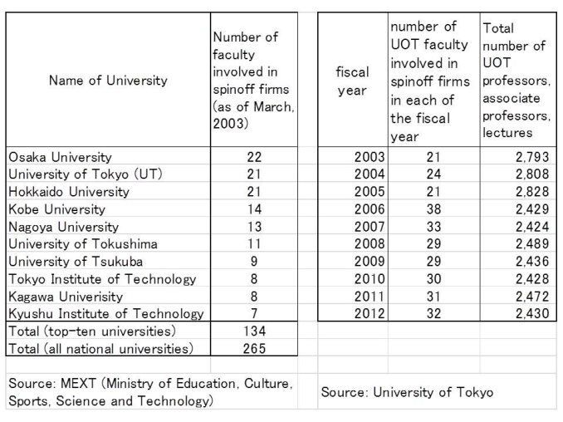

Data Sample

As Table 1 clearly shows, the UOT is one of the main sources of AEs; accordingly, this study investigates scientists working there. As of May 2012, the UOT had 2,430 professors, associate professors, and lecturers with full-time positions. This number includes not only scientists but also humanities and social science specialists. Of 2,430 UOT researchers, this study selected a sample of 551 scientists specializing in one of the following disciplines: engineering, computer science, medicine, pharmaceutical science, and chemistry. This sample group accounts for approximately 23% of all UOT faculty members.
To identify the four types of mobility in the sample, an original database was constructed by consulting various sources, including the official UOT website on which the CVs of many scientists are posted, databases run by Japanese governmental agencies, archived interviews conducted mainly by journalists and UOT students, and the websites of other credible organizations, such as established publishers, large online bookshops, and famous preparatory schools.
Information disclosed in accordance with the Rules of the National Personnel Authority (NPA) enhances the quality of the database because it provides data regarding UOT researchers’ involvement in commercial activities such as creating university spinoff firms or becoming involved in such firms as management board members.

Table 2
AEs and Non-AEs at the UOT
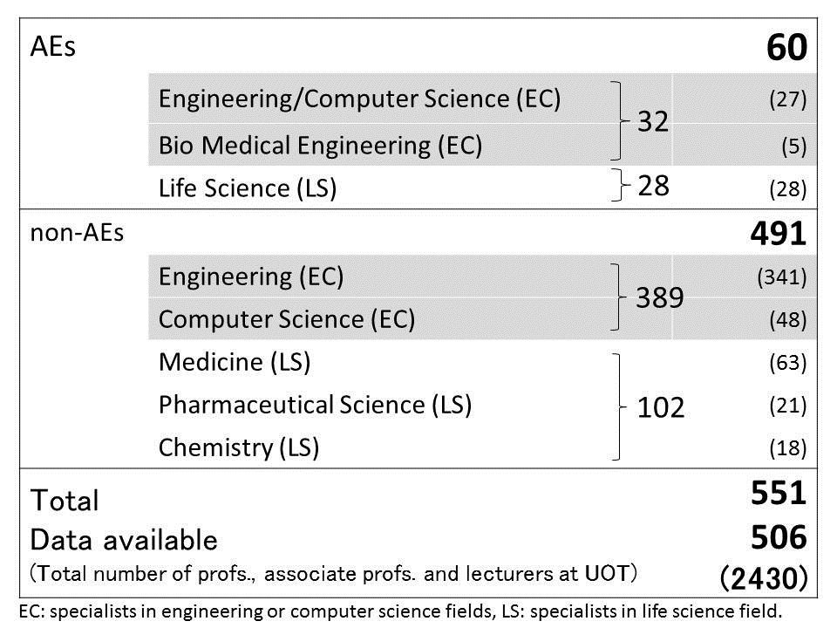

Dependent variable

This study adopts one dependent variable—the probability of becoming an AE—proxied by a dummy variable. The dummy variable takes the value 1 if the scientist has become an AE and 0 otherwise. By referring to the previous study that defined AEs as “university scientists creating university spinoff companies and developing their lab discoveries to meet industrial and social demands (Shane, 2004),” this paper identified AEs as follows: scientists who have full-time positions at UOT, and also, who have created at least one university spinoff firm or who are otherwise members of such a firm’s management board.

Independent variables

This study adopts four independent variables: JM, SM, IM, and EBM. JM, referring to job-switching experience, is a dummy variable taking the value 1 if the scientist has moved from one organization to another after taking a full-time position either at a university or at a company, and 0 otherwise.
SM refers to the experience of working for a private company; this is a dummy variable and takes the value 1 if the scientist was hired by a private company on a lifetime employment contract before joining the UOT and 0 otherwise.
IM refers to the scientist’s past experience of living abroad; this is a dummy variable and takes the value 1 if the scientist worked for a foreign organization, or studied at foreign universities, for at least three years. Unlike the JM and SM dummies, that take the value 1 only if scientists change their affiliations after getting full-time positions, the IM dummy takes the value 1 if the scientists stayed in a foreign country for at least three years whether or not they already had full-time positions. This leads to the expectation that, all else being equal, IM may be more popular than JM and SM.
EBM refers to the educational background of each scientist: this is a dummy variable and takes the value 1 if the scientist received a bachelor’s degree and a Ph.D. from different universities and 0 otherwise.

RESULT AND DISCUSSION

Results

Tables 3 provide the descriptive statistics. It shows the means, medians, mode, standard deviations, and minimum and maximum values. Table 4 contains the correlation matrix. None of the correlation coefficients reach the threshold value of 0.7. To further assess the potential for multicollinearity, this study calculated the variance inflation factors (VIF). For all the models, the maximum VIF value is 1.16. Hence, the results do not suffer from multicollinearity.

Table 3
Descriptive Statistics
Table 4
Correlation Matrix (Spearman)
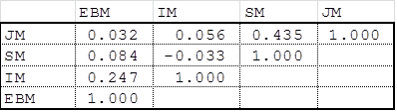

Approximately 11% of UOT scientists are AEs who have created at least one university spinoff firm or who are otherwise members of such a firm’s management board. Meanwhile, roughly half of UOT scientists (0.53) have experienced job switching, after obtaining a full-time position at an organization other than the UOT; the remaining half of the sample consists of stayers who have been at the UOT since securing their positions.
By contrast, SM is quite low (0.18), as is IM (0.12): only 12% of UOT scientists lived in foreign countries for at least three years. Contrary to expectations, IM is the lowest form of mobility among UOT scientists. EBM is also low (0.17); which implies that the majority of UOT scientists have trained mainly at UOT.
Table 5 presents the result of a probit analysis, the relationship between the probability of becoming an AE and the four kinds of mobility. The model in Table 5 supports H1 and H3, confirming that both JM and IM influence UOT scientists to engage in knowledge transfer by creating university spinoff firms.

Table 5
Results
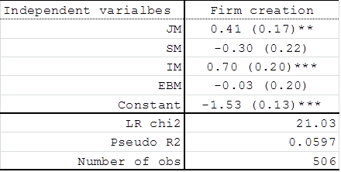
Results of probit estimation. Standard errors in parentheses.
**: significant at 5%, ***: significant at 1%.

A limitation of this analysis should be noted. The empirical analysis did not employ control variables such as gender or age. The sample analysed in this study is overwhelmingly dominated by male researchers (only 9 out of 506 UOT scientists in the sample have female-like names); thus, the control variable for gender would not increase the explanatory power of the probit analysis. Very limited information about the year of birth of individuals in the sample was available, and, therefore, the study could not include a control variable for age. This might impose some limitation on the explanatory power of the model.

Discussion

The result of the empirical analysis suggests that, among UOT scientists, enhanced entrepreneurship that is revealed by their firm-creating activities is associated with JM and IM. This result is corroborated by the existing literature that argued that moving beyond boundaries involves the enhanced entrepreneurship of individuals. Mobile scientists are better positioned than their less mobile peers to form entrepreneurial skills because they have access to rich networks and have gained heterogeneous knowledge through their experience.
Furthermore, scientists with experience of doing research in foreign countries such as the U.S.A. or the UK, which have a wealth of best practices developed by pioneering AEs, may have positive motivations and preferences for entrepreneurial activities. Shane (2004) argued that the growth of spinoff activities is consistent with contagion effects, by which scientists are influenced by the pioneering AEs who have already founded spinoff companies. Pioneering AEs encourage their peers to devote themselves to entrepreneurial activities; as a consequence, several peer scientists decide to start their own spinoffs.
This contagion effect may spread not only among native-born peers but also among peers from other countries, including Japan. Japanese scientists who have visited pioneering AEs in foreign countries and shared research activities with them may have witnessed how well those pioneers had achieved knowledge transfer. They may also have learned how skilfully the pioneering AEs have managed the complicated tasks inherent to entrepreneurial activities. Thus, the Japanese scientists who have shared research activities with pioneering AEs in foreign countries were able to obtain a role model that would help them develop entrepreneurship.
In contrast to JM and IM, SM does not have a positive relationship with entrepreneurship. This implies that previous experience in the business sector does not incubate skills necessary for the commercialization of university research. This counterintuitive insight needs further investigation.
A comparative study of sector-mobile scientists and those with JM and/or IM may provide a clue to this puzzle. Crespi et al. (2007) found differences in that which determines mobility towards universities or business (the former is equivalent to JM and the latter to SM in this study). Their finding implies that sector mobility has a different impact on human capital formation than do JM and IM.
Another possibility for solving the puzzle concerns the difficulty of combining knowledge. Both JM and IM enable AEs to access fresh knowledge embedded in the organization to which they have just moved. Simultaneously, the AEs continue to utilize the familiar knowledge embedded in their previous affiliations, due to the openness of the university sector. Consequently, JM and IM facilitate combining new knowledge with familiar knowledge.
By contrast, sector mobility may not allow mobile scientists to combine the two sources of knowledge due to the knowledge gap between universities and companies. Strict nondisclosure rules imposed on scientists who move to academia from private companies may also hamper the combination.
In the same vein, EBM showed an equivocal impact on entrepreneurship among UOT scientists. Among UOT scientists, those who have multi-educational background consists the minority; meanwhile, in that minority group, the experience of having trained in the heterogeneous research environments have nothing to do with the entrepreneurship. The reason for this relation is under-investigated.
The results of this empirical research clearly showed that among the previously-studied mobility, some, such as JM and IM, enhance entrepreneurship, on one hand; on the other hand, others – SM and EBM – do not. In order to understand the impact of mobility on the status of entrepreneurship among scientists, scholars may need to subdivide mobility into some types according to the positive-effect or negative-effect on the skill-formation of entrepreneurs.

Conclusion

This study explores the mechanism by which mobility influences university entrepreneurship through an empirical analysis of Japanese scientists working for the University of Tokyo. A new dataset composed of credible and varied information facilitated the analysis of more than 500 scientists currently holding full-time positions at the UOT.
Drawing on a theoretical framework for entrepreneurs’ skill formation, this study distinguished between Japanese AEs and non-AEs. This study then compared the career paths of AEs to those of non-AEs. Four kinds of mobility—JM, SM, IM, and EBM—were highlighted. The result of the probit analysis clearly showed that both JM and IM are positively related to university entrepreneurship among scientists at significant levels, whereas SM and EBM are not.
This result indicates that some kinds of mobility encourage Japanese scientists to behave in ways that allow them to gain opportunities for commercializing university research. However, other kinds of mobility do nothing with the entrepreneurship.
Finally, the methodological limits on this study should be mentioned. Since the research was focused on UOT scientists, the general applicability of the analysis is limited. It would be necessary to collect corresponding data from several other national universities to ensure that the result is consistent across Japan’s academic institutions. Moreover, samples from different regions in Japan should be used in order to confirm that the result is robust and consistent across regions. Further research is needed to investigate how each type of mobility interrelates with the university entrepreneurship.

Acknowledgement
This work was supported by JSPS KAKENHI (Grant-in-Aid for Scientific Research) Grant number 25350467.

References
- Ardichvili, A., Cardozo, R., & Ray, S. 2003. A theory of entrepreneurial opportunity identification and development. Journal of Business Venturing 18:105–123.
- Asheim, B.T., & Isaksen, A. 2002. Regional innovation systems: The integration of local ‘sticky’ and global ‘ubiquitous’ knowledge. The Journal of Technology Transfer 27(1): 77-86.
- Baba, Y., Schichijo, N., & Sedita, S. 2009. How do collaborations with universities affect firms’ innovative performance? The role of “Pasteur scientists” in the advanced materials field. Research Policy 38: 756–764.
- Baba, Y., Schichijo, N., & Sedita, S. 2011. Contribution of academic entrepreneurship to scientific progress. Paper presented at the DRUID 2011. http://druid8.sit.aau.dk/acc_papers/gh0x18jqqqi9d5lh11k9qftujer2.pdf. (Accessed January 9, 2015)
- Balconi, M., & Laboranti, A. 2006. University–industry interactions in applied research: The case of microelectronics. Research Policy 35: 1616–1630.
- Bercovitz, F., & Feldman, M. 2007. Academic entrepreneurs and technology transfer: who participates and why? In F. Malerba & S. Brusoni (Eds.), Perspectives on innovation: Cambridge University Press.
- Baldini, N. 2009. Implementing Bayh–Dole-like laws: Faculty problems and their impact on university patenting activity. Research Policy 38:1217–1224.
- Baldini, N. 2010. University spin-offs and their environment. Technology Analysis & Strategic Management 22(8): 859–876.
- Carlsson, B., Acs, Z.J., Audretsch, D.B.,& Braunerhjelm, P. 2009. Knowledge creation, entrepreneurship, and economic growth: Historical review. Industrial and Corporate Change 18(6): 1193–1229.
- Chalamwong, Y. 2004. The migration of highly skilled Asian workers in OECD member countries and its effects on economic development in East Asia. Paper presented at A Joint MOF/PRI-OECD Research Project: The Impact and Coherence of OECD Country Policies on Asian Developing Economies, OECD. http://www.oecd.org/pcd/31857618.pdf (Accessed January 9, 2015)
- Collins, S., & Wakoh, H. 2000. Universities and technology transfer in Japan: Recent reforms in historical perspective. Journal of Technology Transfer 25: 213–222.
- Crespi, G., Geuna, A., & Nesta, L. 2007. The mobility of university inventors in Europe. Journal of Technology Transfer, 32: 195–215.
- Davenport, S. 2004. Panic and panacea: Brain drain and science and technology human capital. Research Policy 33: 617–630.
- D’Este, P., & Patel, P. 2007. University–industry linkages in the UK: What are the factors underlying the variety of interactions with industry? Research Policy 36(9): 1295– 1313.
- D'este, P., Mahdi, S., & Neely, A. 2009. Academic entrepreneurship: What are the factors shaping the capacity of academic researchers to identify and exploit entrepreneurial opportunities? Paper presented DRUID Summer Conference 2009. http://www2.druid.dk/conferences/viewpaper.php?id=5510&cf=32. (Accessed January 9, 2015)
- Edler, J., Fier, H., & Grimpe, C. 2011. International scientist mobility and the locus of knowledge and technology transfer. Research Policy 40(6): 791–805.
- Harayama, Y., Ujiie, Y., & Degawa, T., 2009. Driver of Industrial Innovation: Technology Ventures Fueling Innovation Ecosystem (Sangyo Kakushin no Gensen). Tokyo: Hakuto-Shobo.
- Henderson, R., Jaffe, A., & Trajtenberg, M. 1998. Universities as a source of commercial technology: A detailed analysis of university patenting, 1965-1988, The Review of Economics and Statistics 80(1): 119–127.
- Hills, G., Lumpkin, G.T., & Singh, R.P. 1997. Opportunity recognition: perceptions and behaviors of entrepreneurs. Frontiers of Entrepreneurship Research, Babson College, http://fusionmx.babson.edu/entrep/fer/papers97/hills/hill1.htm.(Accessed January 9, 2015)
- Hormiga, E., & Bolívar-Cruz, A. 2012. The relationship between the migration experience and risk perception: A factor in the decision to become an entrepreneur. International Entrepreneurship Management Journal: 297-317, DOI 10.1007/s11365-012-0220-9
- Grimaldi, R, Kenney, M., Siegel, D., & Wright, M. 2011. 30 years after Bayh–Dole: Reassessing academic entrepreneurship. Research Policy 40: 1045–1057.
- Hunt, J., & Gauthier-Loiselle, M. 2008. How much does immigration boost innovation? NBER Working Paper, 14312. National Bureau of Economic Research. http://www.nber.org/papers/w14312.pdf (Accessed January 9, 2015)
- Kay, C.J. 1986. The Identification of Catalysts Preceding Decision Making as Described by Innovators and Entrepreneurs. San Francisco: University of San Francisco.
- Kneller, R. 2007. The beginning of university entrepreneurship in Japan: TLOs and bio-ventures lead the way. Journal of Technology Transfer 32(4): 435–456.
- Krabel, S., Siegel, D., & Slavtchev, V. 2012. The internationalization of science and its influence on academic entrepreneurship. Journal of Technology Transfer 37: 192–212.
- Krueger, N.J., & Dickson, P.R. 1994. How believing in ourselves increases risk taking: Perceived self-efficacy and opportunity recognition. Decision Sciences 25(3): 385-400.
- Lam, Alice. 2010. From “ivory tower traditionalists” to “entrepreneurial scientists”? Academic scientists in fuzzy university – industry boundaries. Social Studies of Science 40(2): 307–340.
- Lam, Alice. 2011. What motivates academic scientists to engage in research commercialization: “gold,” “ribbon” or “puzzle”? Research Policy 40: 1354–1368.
- Lee, S. 2004. Foreign-born scientists in the United States—do they perform differently than native-born scientists? Doctoral Dissertation, Georgia Institute of Technology. http://archive.cspo.org/rvm/publications/pubs_docs/lee_sooho_200412_phd.pdf (Accessed January 9, 2015)
- Libaers, D., & Wang, T. 2012. Foreign-born academic scientists: entrepreneurial academics or academic entrepreneurs? R&D Management 42(3): 254–272.
- Mosey, S., & Wright, M., 2007. From human capital to social capital: a longitudinal study of technology-based academic entrepreneurs. Entrepreneurship Theory and Practice, November 2007: 909–935.
- Mowery, D., Nelson, R., Sampat, B., Ziedonis, A. 2001. The growth of patenting and licensing by U.S. universities: an assessment of the effects of the Bayh–Dole act of 1980. Research Policy 30: 99–119.
- Mowery, D., Ziedonis, A. 2002. Academic patent quality and quantity before and after the Bayh–Dole act in the United States. Research Policy 31(3): 399–418.
- OECD. 2008. The global competition for talent: Mobility of the highly skilled.
- Richardson, J., & McKenna, S. 2003. International experience and academic careers: what do academics have to say? Personnel Review 32(6): 774–795.
- Sauermann, H., Cohen, W., & Stephan, P. 2010. Doing well or doing good? The motives, incentives, and commercial activities of academic scientists and engineers. Paper presented at the DRUID Summer Conference 2010. http://www2.druid.dk/conferences/viewpaper.php?id=501180&cf=43 (Accessed January 9, 2015)
- Saxenian, A. 2002. Brain circulation: How high-skill immigration makes everyone better off. The Brookings Review 20(1): 28–31.
- Saxenian, A. 2007. The new Argonauts: Regional advantage in a global economy. Cambridge, MA: HUP.
- Schumpeter, J. 1934. Capitalism, socialism, and democracy. New York: Harper & Row.
- Shane, S. 1999. Prior knowledge and the discovery of entrepreneurial opportunities. Organization Science 11 (4): 448–469.
- Shane, S. 2004. Encouraging university entrepreneurship?: The effect of the Bayh-Dole Act on university patenting in the United States. Journal of Business Venturing 19: 127–151.
- Siegel, D., Wright, M., & Lockett, A. 2007. The rise of entrepreneurial activity at universities: Organizational and societal implications. Industrial and Corporate Change 16(4): 489–504.
- Stephan, P., & Levin, S.G. 2001. Exceptional contributions to US science by the foreign-born and foreign-educated. Population Research and Policy Review 20: 59–79.
- Stevenson, H.H., Roberts, M.J., & Grousbeck, H.I. 2000. New business ventures and the entrepreneur (5th ed.). McGraw-Hill.
- Stokes, D.E. 1997. Pasteur’s quadrant: Basic science and technological innovation. Brookings Institution Press.
- Thorn, K. 2009. The relative importance of motives for international self-initiated mobility. Career Development International 14(5): 441–464.
- Von Looy, B., Landoni, P., Callaert, J., van Pottelsberghe, B., Sapsalis, E., & Debackere, K. 2011. Entrepreneurial effectiveness of European universities: An empirical assessment of antecedents and trade-offs. Research Policy 40: 553-564.
- Walsh, J., Baba, Y., Goto, A., & Yasaki, Y. 2008. Promoting university-industry linkages in Japan: Faculty responses to a changing policy environment. Prometheus 26(1): 39–54.
- Wright, M., Clarysse, B., Mustar, P., & Lockett, A. 2007a. Academic Entrepreneurship in Europe. Cheltenham: Edward Elgar.
- Wright, M., Hmieleski, K.M., Siegel, D.S., & Ensley, M.D. 2007b. The role of human capital in technological entrepreneurship. Entrepreneurship Theory and Practice 31(6): 791–806.
- Zucker, L., & Darby, M. 1998, Movement of star scientists and engineers and high-tech firm entry. NBER Working Paper 12

↑ If possible, equalize columns on the last page ↑

